Product Stack Dependency Matrix – ARCON Secrets Management Platform (v10.11.005)

Purpose and audience: This document provides Product Management, Engineering, Security, Quality Assurance, and Operations stakeholders with a consolidated view of the technology stack supporting ARCON Converged Identity v10.11.005. It maps direct and shared dependencies, highlights lifecycle and compatibility risks, and defines the actions required to maintain release readiness, security compliance, and product supportability.
Product Name : ARCON Converged Identity
Product Version : v10.11.005
Release Date : 01 June 2026
Component | Version | Supplier | Type | Dependencies
ARCON Secrets Management Platform | 10.11.005 | ARCON TechSolutions Pvt. Ltd. | Application | .NET
Microsoft .NET Framework | 4.7.2 | Microsoft Corporation | Framework / Runtime | None
.NET (Cross-platform SDK) | 8.0.22 | Microsoft Corporation | Framework | System.Runtime; System.Text.Json
Angular | 14.0.0 | Google LLC | Frontend Framework | rxjs; zone.js; typescript
DBeaver | 25.0.2 | DBeaver Corporation | Application | Java; JDBC Drivers
Putty | 81.2.32 | Simon Tatham | Application | None
Apache Guacamole | 1.6.0 | Apache Foundation | Web Application | Tomcat; MySQL/PostgreSQL; OpenJDK
OpenSSH | 9.8p1 | The OpenBSD Project | Library / Application | OpenSSL; zlib
Microsoft SQL Server | 2019 | Microsoft Corporation | Database Server | Windows OS; .NET Framework
MySQL | 8.4.7 | Oracle Corporation | Database Server | OpenSSL; zlib
Squid | 5.x (OS-dependent) | Squid Software Foundation | Proxy Server | OpenSSL; libxml2; libcap; system libraries
Apache Ignite | 2.17.0 | Apache Software Foundation | Distributed DB / Compute | Java runtime; Ignite modules
Apache Kafka | 3.7.0 | Apache Software Foundation | Event Streaming Platform | Java Runtime; Zookeeper; log4j 2.x
Redis | 7.4.1 | Redis Labs | In-memory DB / Cache | libc; openssl (optional); jemalloc

Executive summary: The release combines legacy and modern runtimes, multiple data platforms, access utilities, and shared open-source libraries. The principal product risks are concentrated in shared cryptographic and compression libraries, the continued use of .NET Framework 4.7.2, and compatibility dependencies across Java-based, database, messaging, and remote-access components. Product Management should govern these risks through an approved compatibility baseline, named ownership, evidence-based release gates, and a time-bound modernization roadmap.
Core runtime: Mix of legacy (.NET Framework 4.7.2) and modern (.NET 8.0.22) runtimes ensure backward compatibility.
Frontend: Angular 14 powers the UI layer, dependent on rxjs, zone.js, and TypeScript.
Middleware & Messaging: Apache Kafka and Redis introduce real-time streaming and caching capabilities.
Databases: SQL Server, MySQL, and Apache Ignite form a hybrid data layer supporting transactional and distributed workloads.
Access & Connectivity: Putty, OpenSSH, Free RDP and Guacamole provide secure remote access and gateway functions.
Networking: Squid acts as a proxy layer, enforcing traffic and access policies.
Shared dependencies: OpenSSL and zlib remain critical across multiple layers — key for encryption and compression.
This stack integrates enterprise-grade Microsoft technologies with open-source distributed and streaming frameworks (Kafka, Ignite, Redis). Dependency hotspots include OpenSSL/zlib, Java runtime, and .NET runtimes, which should be prioritized for patch management and compatibility validation.

Architecture Diagram
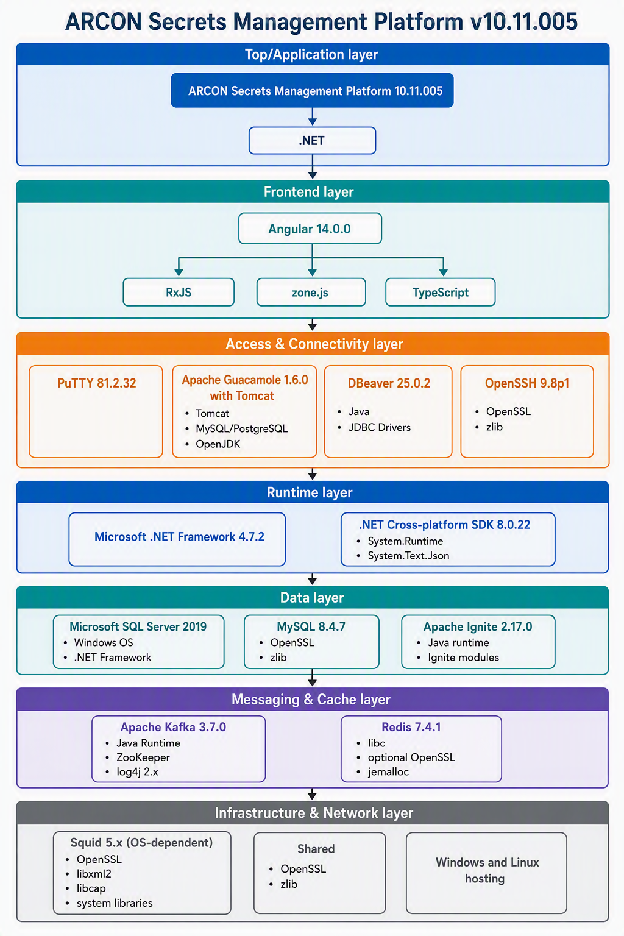
Technology layers:
- Top Layer: ARCON Secrets Management Platform (core application).
- Frontend: Angular 14 with RxJS, Zone.js, TypeScript.
- Access Tools: Putty, Apache Guacamole, DBeaver.
- Database Layer: MS SQL Server 2019, MySQL 8.4.x, Apache Ignite.
- Messaging & Cache: Apache Kafka and Redis for streaming and in-memory operations.
- Middleware & Runtime: .NET Framework 4.7.2, .NET SDK 8.0, Apache Tomcat, OpenSSH.
- Infrastructure: Squid Proxy, OpenSSL & zlib, Linux & Windows servers.
Each layer is color-coded and connected by downward arrows to show dependency flow from the top application layer down to infrastructure.

Supported Component Versions and End of Life Matrix
Component | Currently Supported Versions | End of Life (EOL) / End of Support
Microsoft .NET Framework | • 4.8.1 | • Indefinite (Tied to Windows OS lifecycle)
Microsoft .NET Framework | • 4.8 | • Indefinite (Tied to Windows OS lifecycle)
Microsoft .NET Framework | • 4.7.2 / 4.7.1 / 4.7 | • Indefinite (Tied to Windows OS lifecycle)
Microsoft .NET Framework | • 4.6.2 | • January 12, 2027
Microsoft .NET Framework | • 3.5 SP1 | • January 9, 2029
.NET (Cross-platform SDK) | • .NET 10 (LTS) | • November 14, 2028
.NET (Cross-platform SDK) | • .NET 9 (STS) | • November 10, 2026
.NET (Cross-platform SDK) | • .NET 8 (LTS) | • November 10, 2026
Angular | • Angular 22 | • June 30, 2028
Angular | • Angular 21 | • June 30, 2027
Angular | • Angular 20 | • November 28, 2026
DBeaver | • 26.x (Latest stable: 26.2.0) | • Rolling release model. Only the latest minor version receives active security patches.
PuTTY | • 0.85 (Latest stable release) | • Legacy versions are superseded immediately upon a new security release.
Apache Guacamole | • 1.6.x (Latest stable: 1.6.0) | • Fully backward compatible across 1.x releases; updates are applied forward to the newest stream.
OpenSSH | • 10.x (Latest stable: 10.5) | • Upstream handles active rolling support. Long-term support is typically inherited from your specific operating system's lifecycle (e.g., Ubuntu, RHEL).
OpenSSH | • Older versions packaged via Linux distros
Microsoft SQL Server | • SQL Server 2022 | • January 11, 2033 (Extended Support)
Microsoft SQL Server | • SQL Server 2019 | • January 8, 2030 (Extended Support)
Microsoft SQL Server | • SQL Server 2017 | • October 12, 2027 (Extended Support)
Microsoft SQL Server |  | (Note: SQL Server 2016 reached final EOL on July 14, 2026)
MySQL | • 9.x (Innovation) | • Rolling (Superseded quarterly)
MySQL | • 8.4 LTS | • April 2029 (Premier support window)
MySQL |  | (Note: MySQL 8.0 reached official EOL in April 2026)
Squid | • 6.x / 5.x branches | • Rolling support via operating system backports or jumping to the latest major release branch.
Apache Reverse Proxy (Apache HTTP Server) | Apache 2.4.x | Active (No EOL date announced yet)
 |  | (Version 2.2.x reached EOL on July 11, 2017)
NGINX Reverse Proxy (Open Source) | NGINX 1.31.x (Mainline) | Active
NGINX Reverse Proxy (Open Source) | NGINX 1.28.x / 1.29.x (Stable) | (Legacy branches like 1.27 and earlier are EOL)
FreeRDP | FreeRDP 3.x (Latest: 3.31.x) | Active (Rolling release community support)
FreeRDP | FreeRDP 3.x (Latest: 3.31.x) | (FreeRDP 2.x and below are no longer actively maintained)

Risk Score Heatmap
It layers the architecture with color-coded risk zones:
- 🔴 High Risk (Score 5) → Shared libraries OpenSSL and zlib, used across Infrastructure, Middleware, and Database layers.
- 🟠 Medium Risk (Score 4) → Legacy .NET Framework 4.7.2, SQL Server 2019, MySQL 8.4.7, Apache Ignite, and OpenSSH.
- 🟡 Low–Medium Risk (Score 3) → Access tools (Putty, Guacamole, DBeaver) and the ARCON application layer.
- 🟢 Low Risk (Score 2) → Frontend stack (Angular 14, RxJS, Zone.js, TypeScript) and messaging/cache components (Kafka, Redis) with active patch support.

Top 3 Risk Priorities – ARCON Secrets Management Platform
1. OpenSSL & zlib (Score 5 – High Risk)
- Shared across Infrastructure, Middleware, and Database layers.
- Any CVE affects multiple components simultaneously.
- Action: Continuous CVE monitoring and immediate patch rollout.
2. Legacy .NET Framework 4.7.2 (Score 4 – Medium Risk)
- Limited support; only security patches available.
- Dependency for core application and SQL Server.
- Action: Plan migration to .NET 8 SDK; enforce patch compliance.
3. Database & Messaging Engines (Score 4 – Medium Risk)
- SQL Server, MySQL, Apache Ignite, Kafka, Redis.
- Dependencies on OpenSSL and Java Runtime.
- Action: Apply cumulative updates, vendor advisories, and harden configurations.
Product Management should prioritise three outcomes: maintain rapid patching and monitoring for shared encryption and compression libraries; approve and track a phased migration from .NET Framework 4.7.2 to a supported modern runtime; and enforce lifecycle, compatibility, and hardening controls for database, messaging, cache, and remote-access components. These measures address the most significant sources of systemic vulnerability and release disruption across the Secrets Management stack.

OS Lifecycle & Compatibility
OS | Version | Support Status | Key Lifecycle Milestones
Windows Server | 2019 | Supported (Extended) | Mainstream support ended in Jan 2024. Receives security-only patches until January 9, 2029.
Windows Server | 2022 | Supported | Mainstream support ends October 13, 2026, after which it receives security-only updates until October 14, 2031.
RHEL | 8.x | Supported (Maintenance) | Full support ended in May 2024. Final minor release (8.10) receives security/bug maintenance until May 31, 2029.
RHEL | 9.x | Supported | Active Full Support runs until May 31, 2027, followed by Maintenance Support until May 31, 2032.
Ubuntu Server | 22.04 LTS | Supported | Standard public security updates run until April 2027, with Extended Security Maintenance (ESM) available through April 2032.

Strategic Suggestions
- For Windows environments: Consider adding Windows Server 2025 as the "Recommended" version for new deployments to maximize the lifespan of the OS architecture.
- Also, currently TLS 1.2 is supported. Support for TLS 1.3 is required to be included.
- For Ubuntu environments: Consider validating or adding Ubuntu Server 24.04 LTS as a newer "Recommended" tier option, since 22.04 LTS is nearing the end of its 5-year standard support window next year.

Browser Support
Browser | Supported Versions
Google Chrome | Latest 3 Versions
Microsoft Edge | Latest 3 Versions
Safari | Latest Version

Identity Sources Support
Component | Supported Versions
Microsoft Active Directory | 2016, 2019, 2022
Azure AD / Entra ID | Supported
OpenLDAP | 2.5.x, 2.6.x
Okta | Supported
PingFederate | Supported

MFA Integration Support
Component | Supported
Microsoft Authenticator | Yes
Google Authenticator | Yes
RSA SecurID | Yes
Duo Security | Yes
FIDO2 Security Keys | Yes

